1.Write a simple console application calculator with the help of Visual studio .NET IDE which will perform following operations on two numbers.

using System;

using System.Collections.Generic;

using System.Linq;

using System.Text;

using System.Threading.Tasks;

namespace CalculatorApp

{

class Program

{

static void Main(string[] args)

{

Console.WriteLine("Enter the action to be performed");

Console.WriteLine("Press 1 for Addition");

Console.WriteLine("Press 2 for Subtraction");

Console.WriteLine("Press 3 for Multiplication");

Console.WriteLine("Press 4 for Division \n");

int action = Convert.ToInt32(Console.ReadLine());

Console.WriteLine("Enter 1st input");

int input_1 = Convert.ToInt32(Console.ReadLine());

Console.WriteLine("Enter 2nd input");

int input_2 = Convert.ToInt32(Console.ReadLine());

int result = 0;

switch (action)

{

case 1:

{

result = Addition(input_1, input_2);

break;

}

case 2:

{

result = Subtraction(input_1, input_2);

break;

}

case 3:

{

result = Multiplication(input_1, input_2);

break;

}

case 4:

{

result = Division(input_1, input_2);

break;

}

default:

Console.WriteLine("Wrong action!! try again");

break;

}

Console.WriteLine("The result is {0}", result);

Console.ReadKey();

}

//Addition

public static int Addition(int input_1, int input_2)

{

int result = input_1 + input_2;

return result;

}

//Substraction

public static int Subtraction(int input_1, int input_2)

{

int result = input_1 - input_2;

return result;

}

//Multiplication

public static int Multiplication(int input_1, int input_2)

{

int result = input_1 * input_2;

return result;

}

//Division

public static int Division(int input_1, int input_2)

{

int result = input_1 / input_2;

return result;

}

}

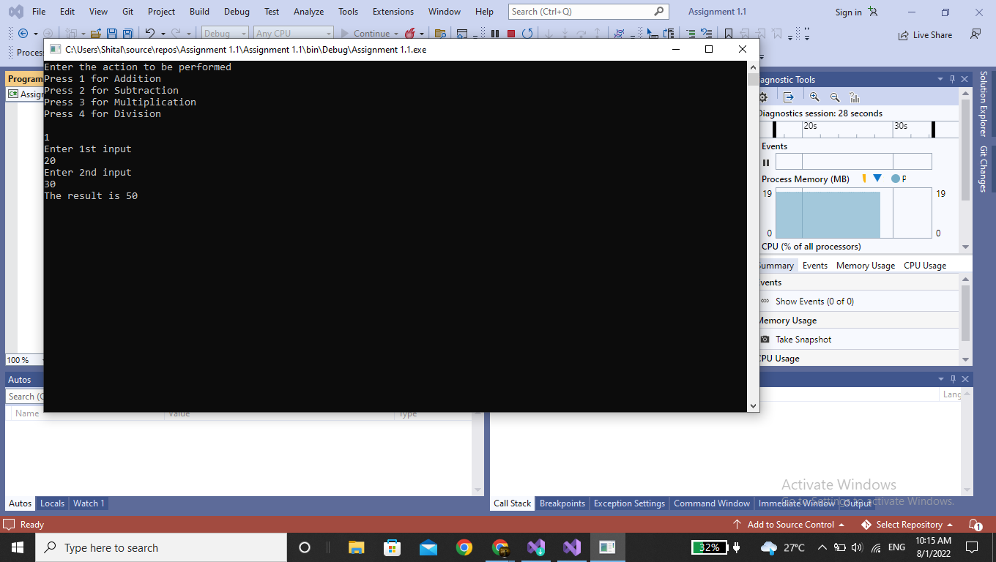

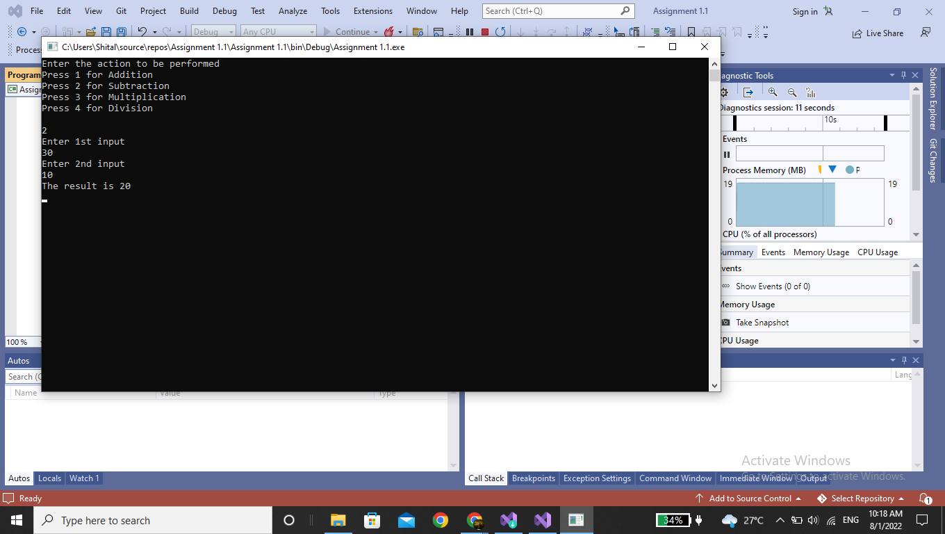

2. Accept average marks of five students. Display the highest marks obtained.

using System;

using System.IO;

using System.Collections.Generic;

using System.Linq;

using System.Text;

using System.Threading.Tasks;

namespace CalculatorApp

{ public class assignment

{

public static void Main()

{

double student1, student2, student3, student4, student5;

Console.Write("Enter the First student: ");

student1 = Convert.ToDouble(Console.ReadLine());

Console.Write("Enter the Second student: ");

student2 = Convert.ToDouble(Console.ReadLine());

Console.Write("Enter the third student: ");

student3 = Convert.ToDouble(Console.ReadLine());

Console.Write("Enter the fourth student: ");

student4 = Convert.ToDouble(Console.ReadLine());

Console.Write("Enter the fifth student: ");

student5 = Convert.ToDouble(Console.ReadLine());

double result = (student1 + student2 + student3 + student4 + student5) / 5;

Console.WriteLine("The average of {0}, {1}, {2}, {3} , {4} is: {5} ",

student1, student2, student3, student4, student5, result);

}

}

}

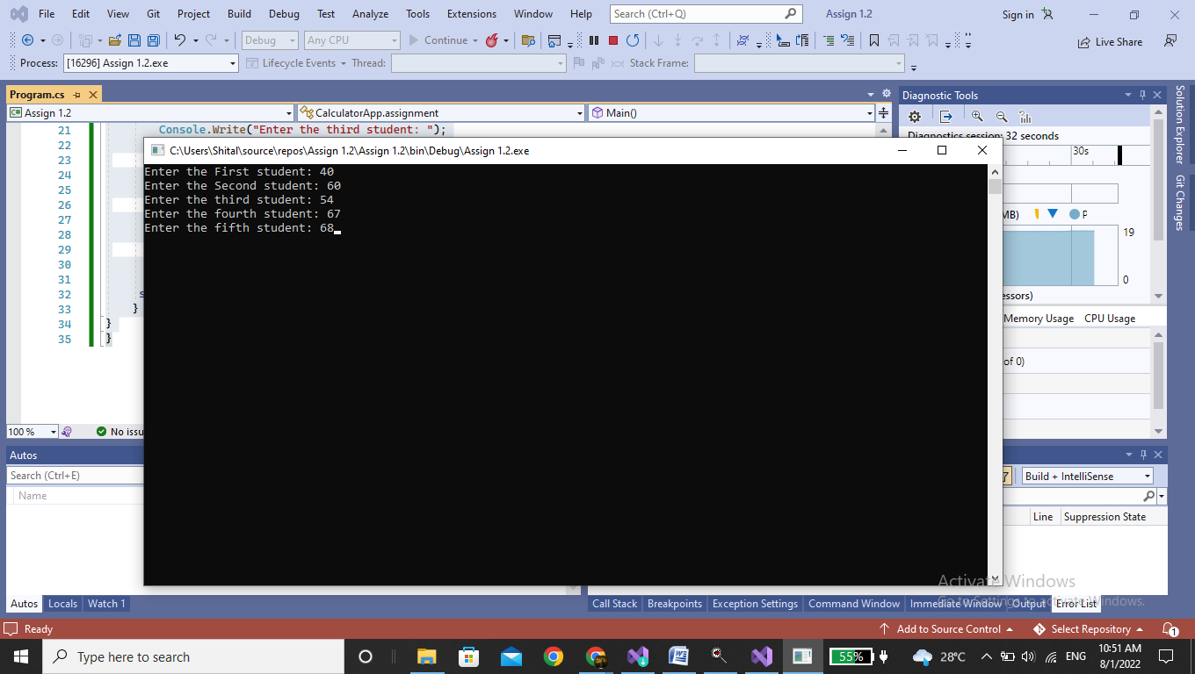

3. Write a method to swap two integers. The client code should call the method and print the swapped value.

using System;

using System.Collections.Generic;

using System.Linq;

using System.Text;

using System.Threading.Tasks;

namespace Assign_1._3

{

class Program

{

static void SwapNum(ref int x, ref int y)

{

int tempswap = x;

x = y;

y = tempswap;

}

static void Main(string[] args)

{

int a = 140;

int b = 450;

Console.WriteLine("Value of a and b before sawapping");

Console.WriteLine();

Console.WriteLine("a=" + " " + a);

Console.WriteLine("b=" + " " + b);

SwapNum(ref a, ref b);

Console.WriteLine();

Console.WriteLine("Value of a and b after sawapping");

Console.WriteLine();

Console.WriteLine("a=" + " " + a);

Console.WriteLine("b=" + " " + b);

Console.ReadLine();

}

}

}

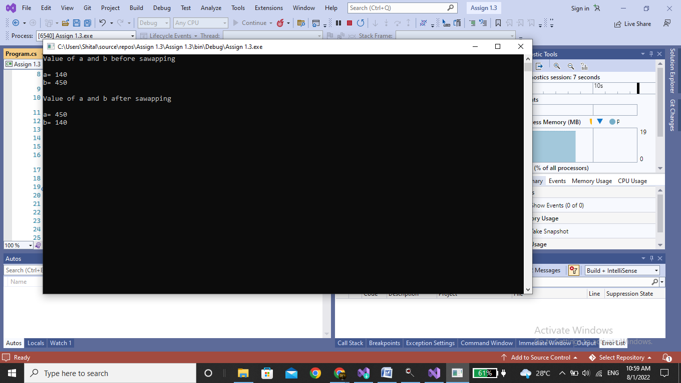

4. Write a static method to accept param array of integers. The method should find the sum of all the integers passed and display the result. Write a client program to call the method.

using System;

using System.Collections.Generic;

using System.Linq;

using System.Text;

namespace array_parameter

{

class Program

{

static void printarray(int[] newarray)

{

int i, sum = 0;

Console.Write("\n\nYou entered: ");

for (i = 0; i < 4; i++)

{

Console.Write("{0}\n", newarray[i]);

sum = sum + newarray[i];

}

Console.Write("\n\nAnd sum of all value is:\n{0}", sum);

Console.ReadLine();

}

static void Main(string[] args)

{

int[] arr = new int[4];

int i;

for (i = 0; i < 4; i++)

{

Console.Write("Enter number: ");

arr[i] = Convert.ToInt32(Console.ReadLine());

}

// passing array as argument

Program.printarray(arr);

}

}

}

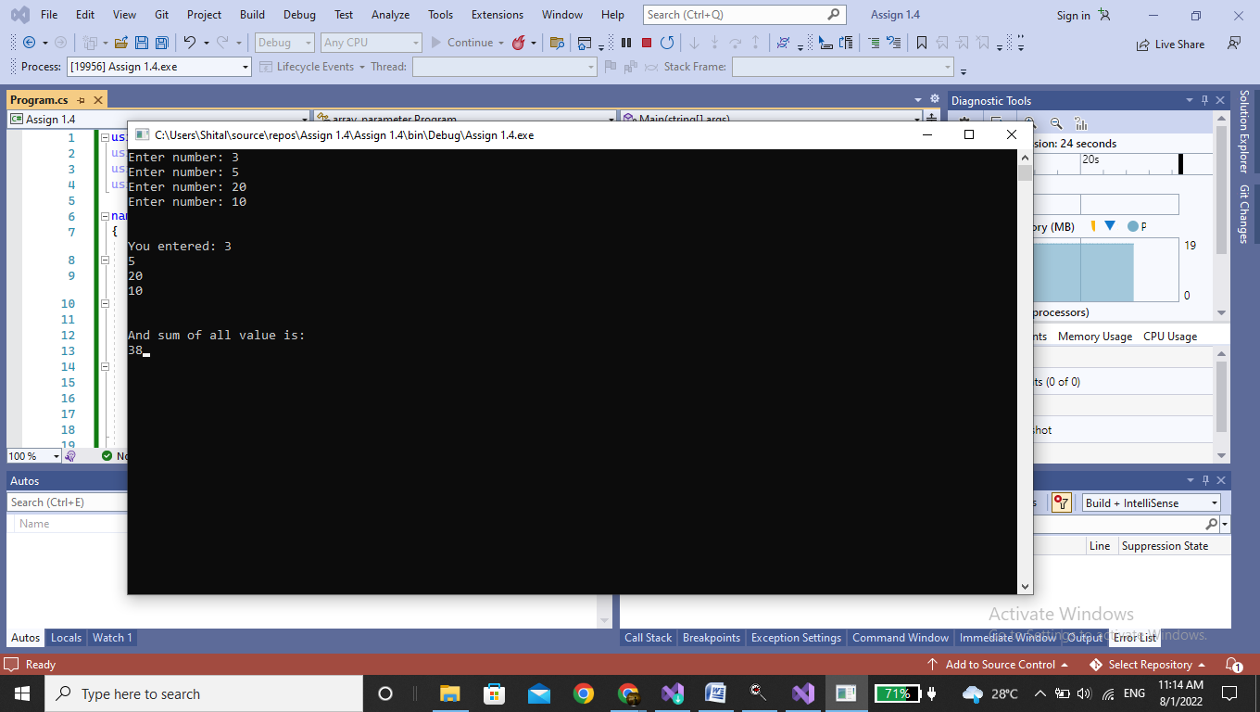

5. Write a single method that calculates the area and circumference of the circle. The area and circumference should be displayed through the client code.

using System;

class Circle

{

static float _PI;

int _Radius;

static Circle()

{

Circle._PI = 3.141f;

}

public Circle(int Radius)

{

this._Radius = Radius;

}

public float CalculateArea()

{

return Circle._PI * this._Radius * this._Radius;

}

}

class program

{

public static void Main()

{

Circle C1 = new Circle(5);

float Area1 = C1.CalculateArea();

Console.WriteLine("Area= {0}", Area1);

Circle C2 = new Circle(6);

float Area2 = C2.CalculateArea();

Console.WriteLine("Area= {0}", Area2);

}

}

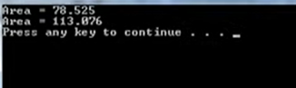

6. Create a structure Book which contains the following members.

Bookid, title, price, booktype.

Type of the book should an enumerated data type with values as magazine, Novel, referencebook, Miscellaneous. Write a console based applications to do the following tasks.

1. Accept the details of the book
2. Display the details of the book. The type of book should be displayed as a string .

using System;

struct book

{

public string title;

public string author;

public string bookid;

public string price;

public string booktype;

}

public class program

{

public static void Main()

{

int nobook = 1000;

book[] books = new book[nobook];

int i, j, n = 1;

Console.Write("\n\nInsert the information of book :\n");

Console.Write("-----------------------------------------\n");

for (j = 0; j <= n; j++)

{

Console.WriteLine("Information of book :");

Console.Write("Input name of the book : ");

books[j].title = Console.ReadLine();

Console.Write("Input name of the booktype:");

books[j].booktype = Console.ReadLine();

Console.Write("Input name of the bookid.:");

books[j].bookid = Console.ReadLine();

Console.Write("Input the price :");

books[j].price = Console.ReadLine();

Console.Write("Input the author : ");

books[j].author = Console.ReadLine();

Console.WriteLine();

}

for (i = 0; i <= n; i++)

{

Console.WriteLine(" Title = {1}, Author = {2}, bookid = {3}, price = {4}, booktype = {5}, i + 1, books[i].title, books[i].author, books[i].bookid, books[i].price, books[i].booktype");

Console.WriteLine();

}

}

}

